
Company
Logotype

Cone Beam Computed Tomography- Report



Porur Dental X-rays & CBCT

Patient Name : Master. Kavin | Date of Report : 11.07.2024
Age/ Gender :6 years/ Male | Region of Interest : CBCT Maxilla
Referring doctor: Dr. Vishnu Charan | Indication : Trauma irt upper front teeth
Clinical Notes: Nil
PATIENT INFORMATION

CBCT Maxilla provided
CBCT – IMAGE DETAILS

RADIOGRAPHIC INTERPRETATION

- Mixed dentition present.
- Missing teeth: 61, 62, 63 (h/o trauma).
- Permanent successors present in relation to 51, 52, 53, 54, 55, 61 region, 62 region, 63 region, 64, 65.
- The permanent teeth are present with normal follicular space.
- The left nasal passage is narrow when compared to the right side.

RADIOGRAPHIC IMPRESSION


- Premature loss of teeth due to trauma: 61, 62, 63

IMAGES FOR REFERENCE

RECONSTRUCTED PANORAMA VIEW
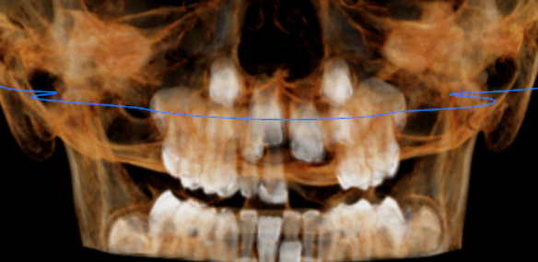
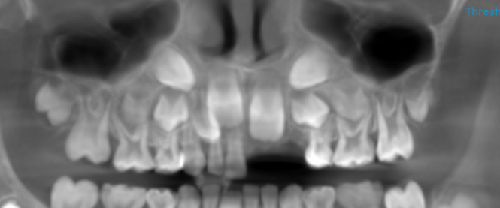
3-DIMENSIONAL VIEW
CROSS- SECTIONAL IMAGES
21, 22, 23 REGION | 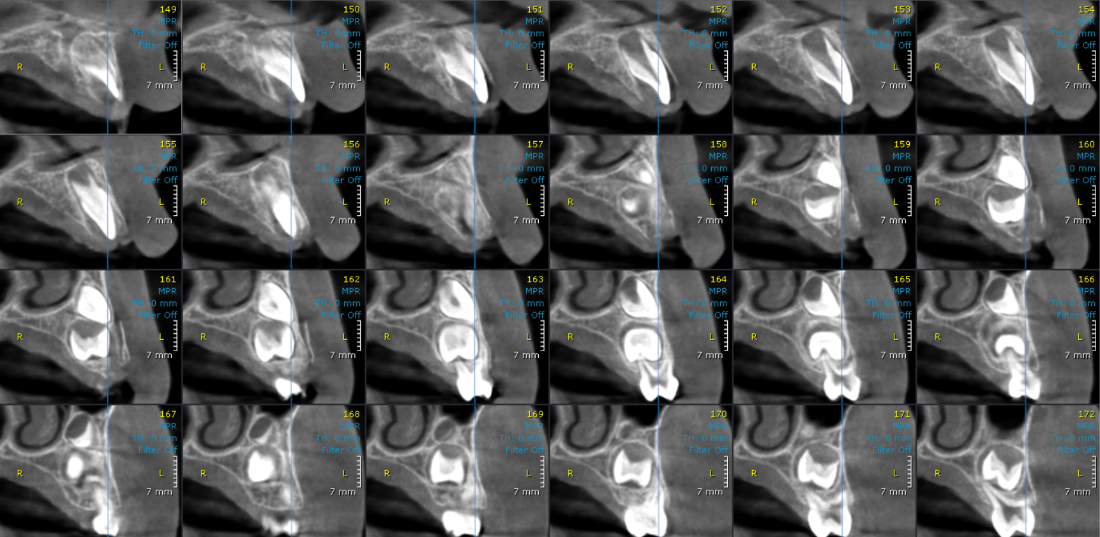

**** End of report ****

